**Assignment 9**

**TCOD01**

test> use mydb

switched to db mydb

mydb> db.createCollection('Teacher_info')

{ ok: 1 }

mydb> db.Teacher_info.insert({Teacher_id:'Pic001', Teacher_Name:'Ravi', Dept_Name:'IT', Sal:30000, status:'A'})

DeprecationWarning: Collection.insert() is deprecated. Use insertOne, insertMany, or bulkWrite.

{

acknowledged: true,

insertedIds: { '0': ObjectId("635e54b0237fc1e5e0fbacd6") }

}

mydb> db.Teacher_info.insert({Teacher_id:'DIT002', Teacher_Name:'A', Dept_Name:'IT', Sal:50000, status:'A'})

{

acknowledged: true,

insertedIds: { '0': ObjectId("635e5569237fc1e5e0fbacd7") }

}

mydb> db.Teacher_info.insert({Teacher_id:'VIT003', Teacher_Name:'Akshay', Dept_Name:'IT', Sal:25000, status:'N'})

{

acknowledged: true,

insertedIds: { '0': ObjectId("635e5585237fc1e5e0fbacd8") }

}

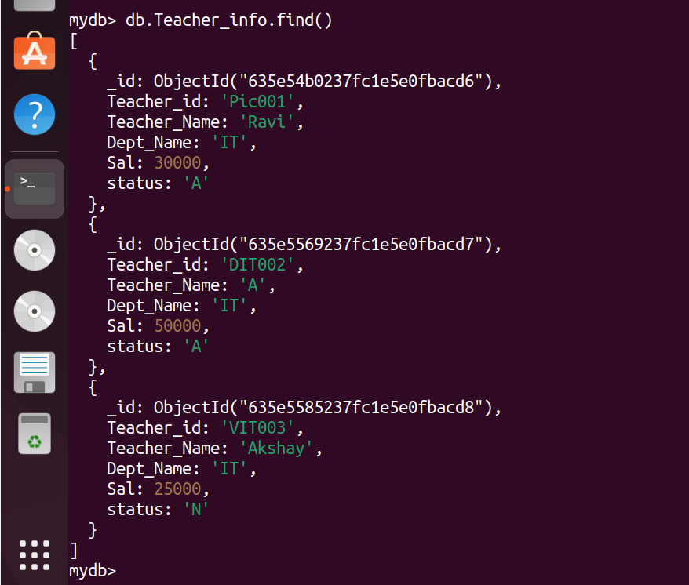

mydb> db.Teacher_info.find({Sal:25000})

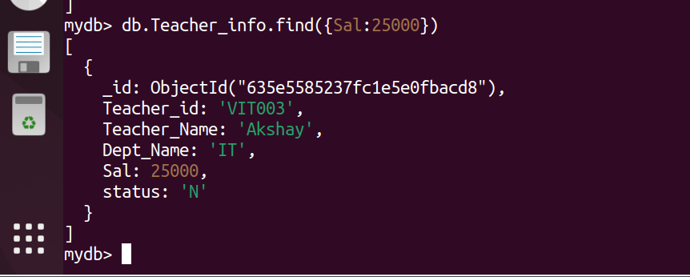

db.Teacher_info.find( {Teacher_id: 'Pic001'})

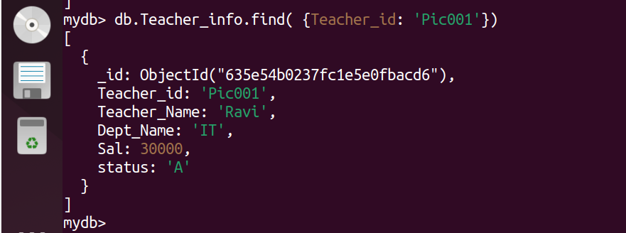

mydb> db.Teacher_info.find( { status: "A" } ).sort( {Sal: -1 } )

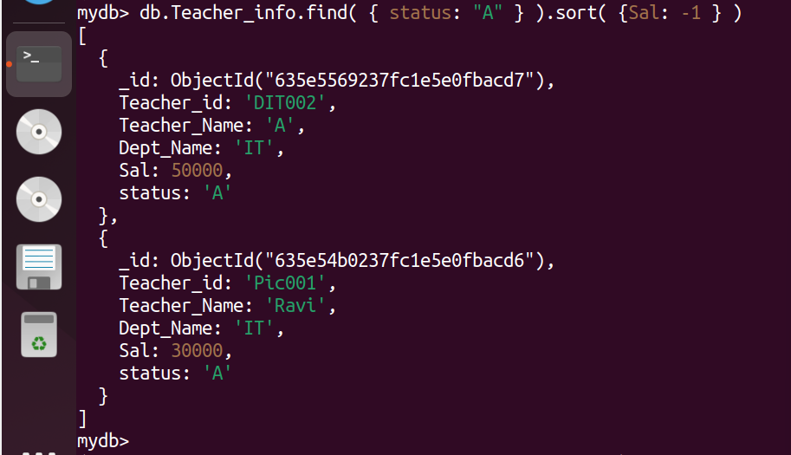

mydb> db.Teacher_info.update( { Sal: { $gt: 20000 } }, { $set: { Dept_Name: "ETC" } }, { multi: true } )

mydb> db.Teacher_info.remove({Teacher_id: "Pic001"});

